1st Grade Word Wall Word List
    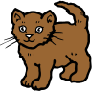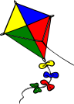Aa | Bb | Cc | Dd | Ee | Ff | Gg | Hh | Ii   | Jj   | Kk | Ll | Mm
a  and  am  are  at  all  any  about  away  always  again  after  answer | be  big  but  because  by  both  back | can  come  can’t  change  could  came | do  down  did  day  don’t | every  eye  earth | for  first  from  four  favorite  friend  father | go  got  get  going  great | he  here  have  his  her  has  hug | I  is  it  in | just  jump | kind  know | like  look  little  long | me  my  make  many  mother  made  more

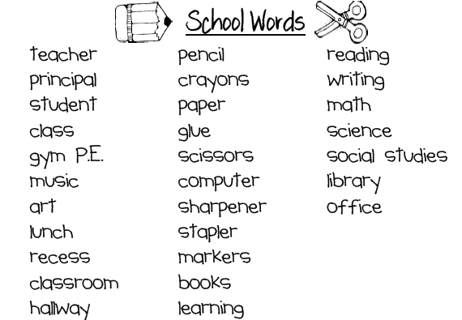
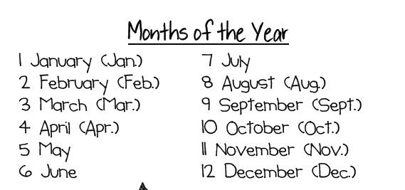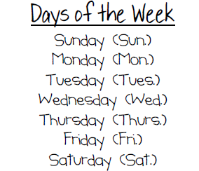

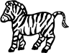  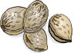    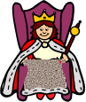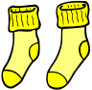Nn | Oo | Pp | Qq | Rr | Ss | 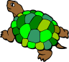Tt | Uu | Vv | Ww | Xx | Yy | Zz
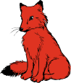no  nice  now  night  nine | on  of  or  out  one  only  over | people |  | run  really  right  rain  ride | said  see  she  some  saw  stop  should | the  to  this  they  them  then  that  there  their  these  those  two  too  thank  treat  thought  through | up  use | very | we  will  went  with  want  when  what  went  was  who  why  would  work  world  which  walk |  | yes  you  your  year | zip

People Matsunaga People First Grade Favorites
Mom Mrs. Brubaker birthday team
Dad Ms. Dawson party present
brother Mr. Doerrman weekend love
sister Mrs. Fouchè movie class
Grandma Mr. Gordon friend family
Grandpa Miss Grinham play Germantown
cousin Mrs. Liu soccer Boyds
aunt Mrs. McLeod baseball Maryland
uncle Mrs. Moxley draw house
Mrs. Putonen color apartment

