Name __________________ March Homework
Choose at least 10 squares to complete. Color the square after you have completed it. Return this chart and the Reading Log by March 21st to get a prize. Parent Signature ___________________________

Reading | Math | Writing | Science/  Social Studies | Other
1 | 2 | 3 | 4 | 5
6 | 7 | 8 | 9 | 10
11 | 12 | 13 | 14 | 15
16 | 17 | 18 | 19 | 20

Reading | Math | Writing | Science/  Social Studies | Other
1.  3-2-1 Reading  Read a book or magazine article. Tell 3 things you remember from the text. Ask 2 questions you still have about the text. Tell your 1 favorite part. | 2.  Create a “Mystery Number Sentence”  Give at least 3 clues and then write your number sentence under your clues. Repeat 4 more times (for a total of 5 mystery number sentences).  For example:  My sum is 10.  I do not have a 5.  All of my numbers are even.  Answer: 4 + 6 = 10 | 3.  Dr. Seuss was born on March 2, 1904. In honor of his birthday, write about your favorite Dr. Seuss book. Be sure to include the title of the book and 2 or 3 reasons why you like it. | 4.  Go outside and take a look at your house. What materials is it made of? Discuss with an adult why the building materials used to make your house were a good choice. | 5.  Write a story about something that makes you smile!
6.  Read a book from home or one you got in class. Write down 3 words that you didn’t know before you read the book. Write or draw what each word means. | 7.  Visit the website:  http://www.funbrain.com/brain/MathBrain/MathBrain.html  Play the math arcade for at least 10 minutes. | 8.  Write about a time you felt lucky. What happened? Be sure to include details and transition words  like first, next, then,  last to make your  writing flow smoothly. | 9.  Check through your recycling bin. Choose at least 1 item. Discuss ways with a grown-up how that item can be reused. | 10.  Legend says that if you catch a Leprechaun, they will give you gold. Write what you would do if you caught a Leprechaun and he gave you gold.
11.  Read a book to someone at home. Act out the problem and solution of the book. | 12.  Roll a Related Fact  Roll 2 dice. Use the two numbers you roll and the sum to make one addition and one subtraction related fact. Repeat 9 more times (for a total of 10 related problems).  ___ + ___ = ___  ___ - ___ = ___  Example:  I rolled a 4 and 6:  4 + 6 = 10  10 - 6 = 4 | 13.  Write 5 questions you would ask a leprechaun if you were lucky enough to catch one. | 14.  Visit the National Geographic Website to play the Recycle Roundup Game!  http://images.nationalgeographic.com/wpf/media-content/richmedia/1/1143/project/dist/desktop.html | 15.  Children’s Poetry Day is March 21st. Find a poem and read it aloud to someone at home.
16.  Read a book to someone at home. Talk about if the story reminds you of anything from your life. Discuss parts of the text that surprised you. | 17.  Write 5 addition and 5 subtraction problems. Then, rewrite each problem so that the equal sign is in a different positon.  Example:  4+5=9 9=5+4  10-7=3 3=10-7 | 18.  Make a list of all the green things you can find in and around your house. How many can you find? | 19.  Make a list of ways people can protect the environment (land, air and/or water). | 20.  Spring begins March 20th. What are some activities you like to do in the spring? Make a list of your favorite spring activities.

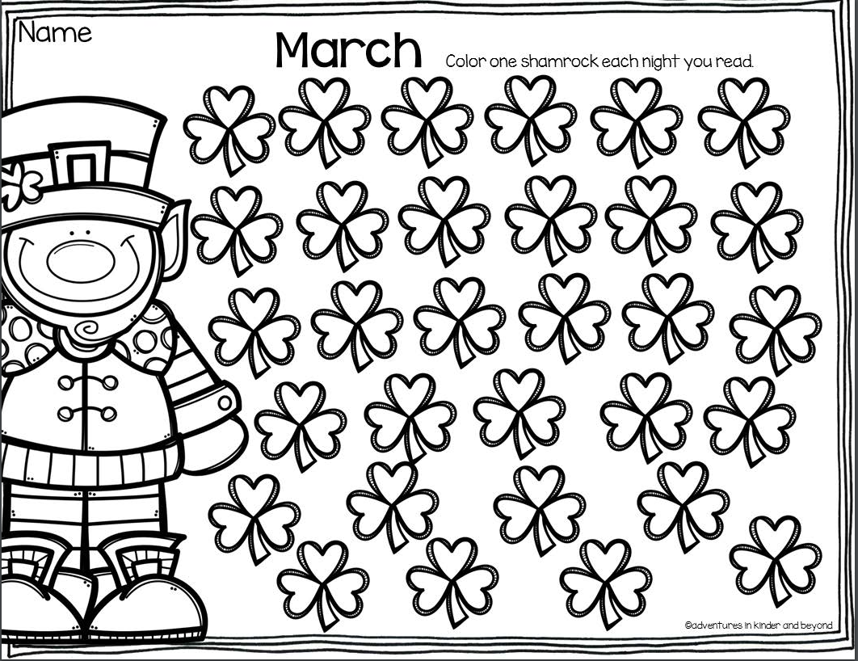
Show your work here (if needed).

Show your work here (if needed).

Show your work here (if needed).
__________________________________________________________________________________________________________________________________________________________________________________________________________________________________________________________________________________________________________________________________________________________________________________________

Show your work here (if needed).
__________________________________________________________________________________________________________________________________________________________________________________________________________________________________________________________________________________________________________________________________________________________________________________________

