



**Longview Warrior Drive**

October 2nd – November 17th

Donations can be

dropped off at

**Matsunaga** or

**Longview** Offices

**Needed & Wanted Items: (*All items must be New & Unused)***

**TOILETRIES: Body wash, Shampoo, Conditioner, Travel Size Lotion, Mouthwash, Lip Balm, Toothbrush, Toothpaste, Deodorant, Electric Shaver, Hair Brush, Comb, & Detergent pods**

**CLOTHING: (Small to XL Black/Grey/Navy Blue), Open Bottom Sweatpants, Sweatshirts, & Plain Athletic Shorts**

**MONETARY: Visa/Master/ Amazon/ Gas/Grocery/Dunkin Doughnuts/ & Subway Gift Cards, & International Phone Cards**

**ELECTRONICS: Xbox 360, New Release PS4 Games, PS4 Wireless Controllers, IPad, & IPod Touch**

**OTHER: Quilts/Blankets, Baby Toys, Legos, Colored Pencils, Crayons, & Coloring Books for Children & Adults**

**FOOD: Nuts, Healthy Snacks, & Healthy Canned food items (not expired)**



Most Items donated classroom will receive…….

Matsunaga – Pizza Party Longview – Five Below Gift Card

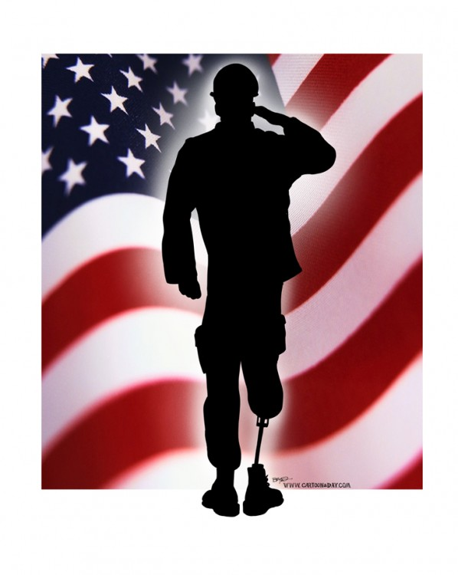

Help us collect needed items to support

**The Wounded, Ill, and Injured Soldiers at**

Walter Reed Medical Center **and their Families!**