1st Grade Homework Schedule
 | Monday | Tuesday | Wednesday | Thursday | Friday
Homework Given | Book Club – Reread Book in Book Club Baggie and complete a Written Response (starting October 7)  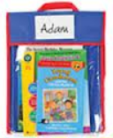 | 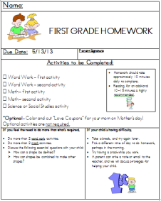  Weekly Homework Packet | Book Club – Reread Book in Book Club Baggie
Homework Due | Weekly Homework Packet  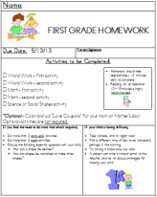 | Bring in Book Club Baggie with Book and Written Response |  | Bring in Book Club Baggie with Book

Every night is a great night to practice reading!

